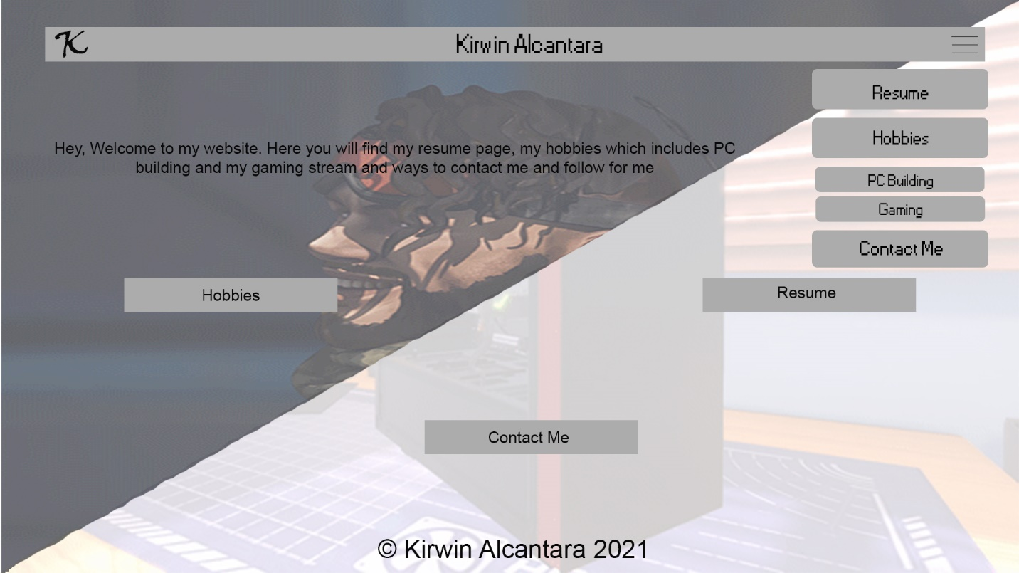

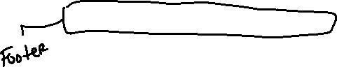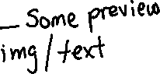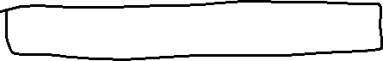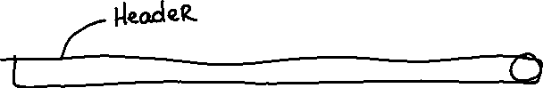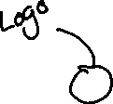

This is roughly the final thought for the main page. The background will have GIFs to have some dynamic feeling to the website. The Navigation bar is expanded here to show how it will look. The buttons might be bigger to get rid of whitespace or include descriptors each button there. Or the boxes needed for P4 if I remember the previous submissions that you showed us in class.

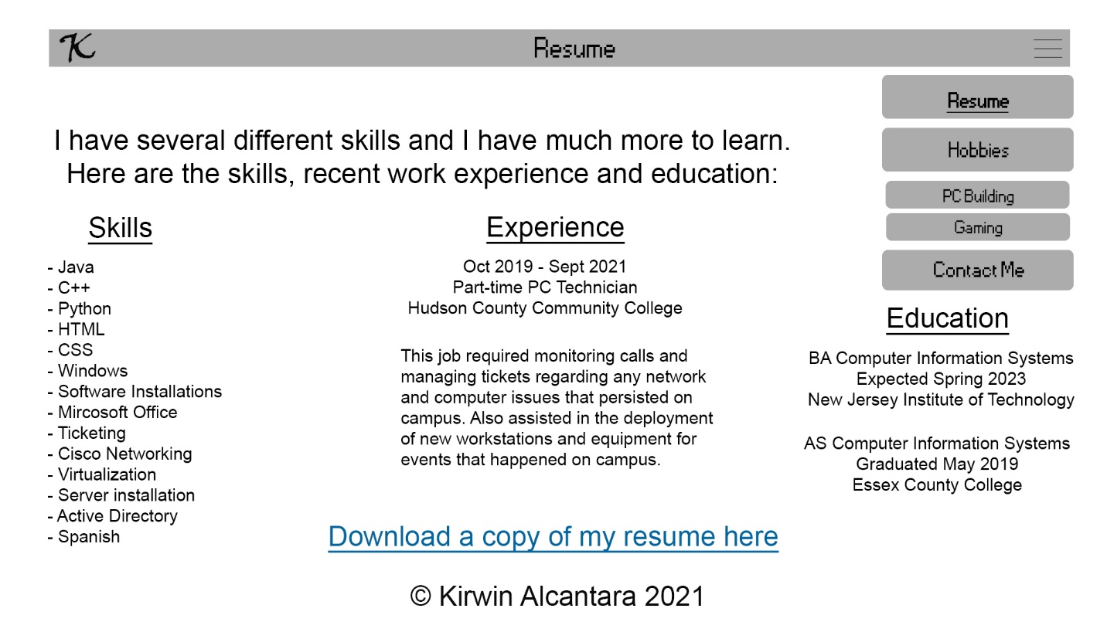

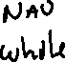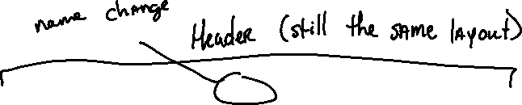

This is the Resume page; I don’t have a background in mind here yet. It’s a web version of my actual resume and it will include a downloadable version of it as well. Take note on the Navigation bar: the bold and underlined page will show what page the user is currently on. Also on production, the education part will not be that low and aligned with the rest of the headers, it was only there to not be blocked by the navigation bar. The logo will be return home, might include that when you hover that it says home or use Javascript to have it fade-in “Home” when you hover, I don’t know yet.

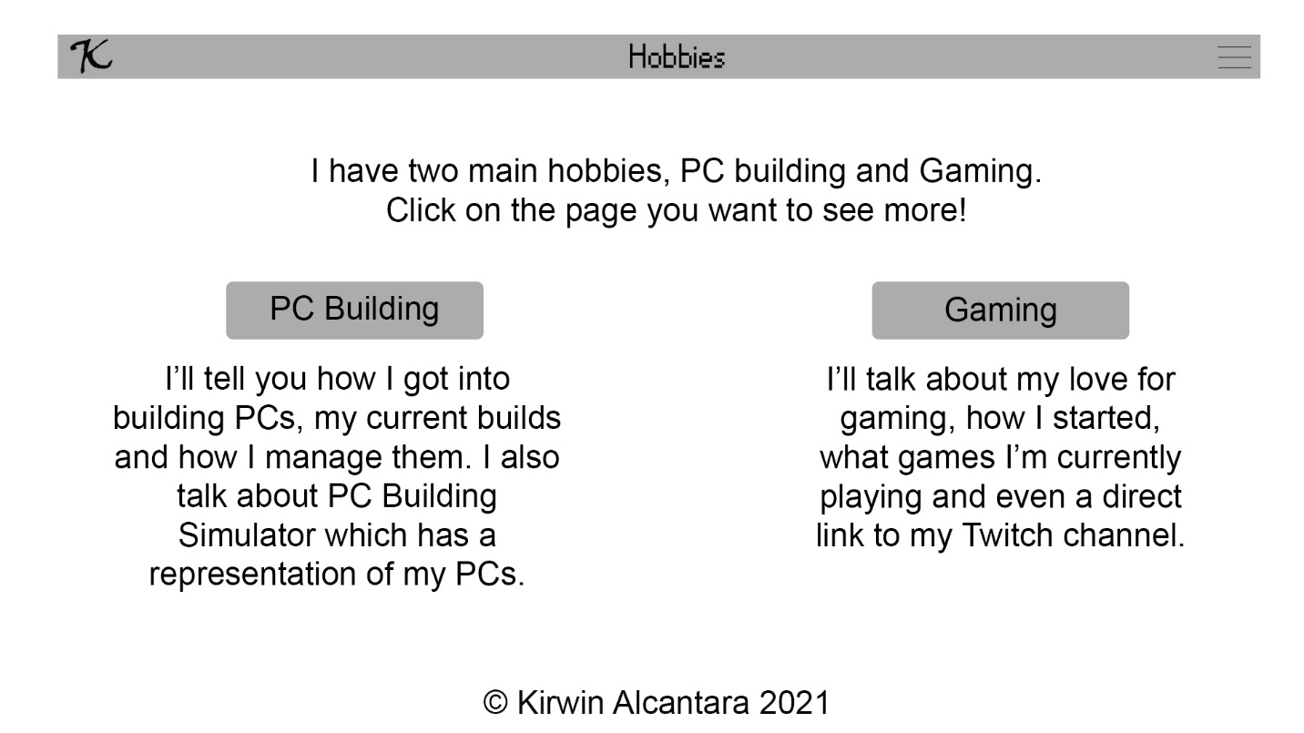

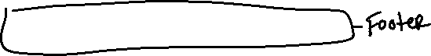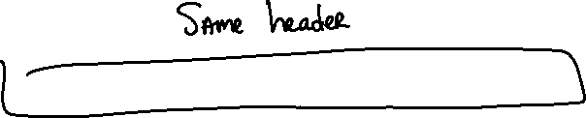

The Hobbies page also doesn’t have a background as of now. I might split it again like I did on the home page but with an image instead of GIFs. For the most part, the layout will be the same. The navigation bar is gone for the rest of the wireframe for an accurate approximation to the final site.

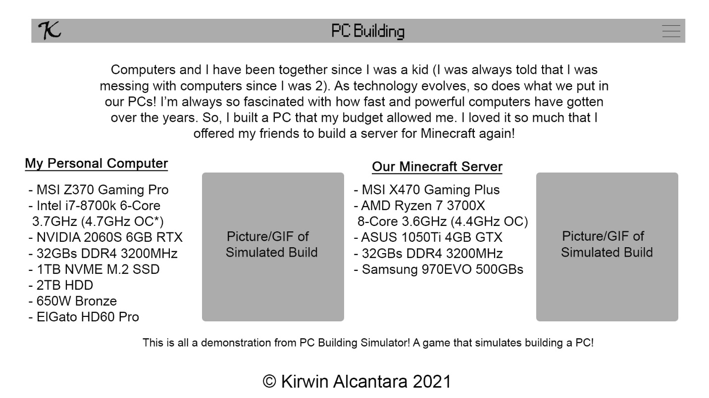

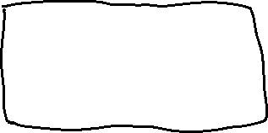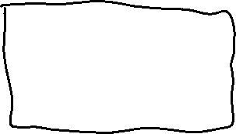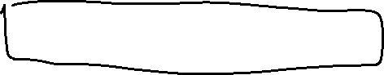

This is the roughly the final layout. No background yet and I’m not too sold on how the text above looks but the PC and server specifications looks great for now. The mobile page will have the specifications, GIF of the personal computer and then the server.

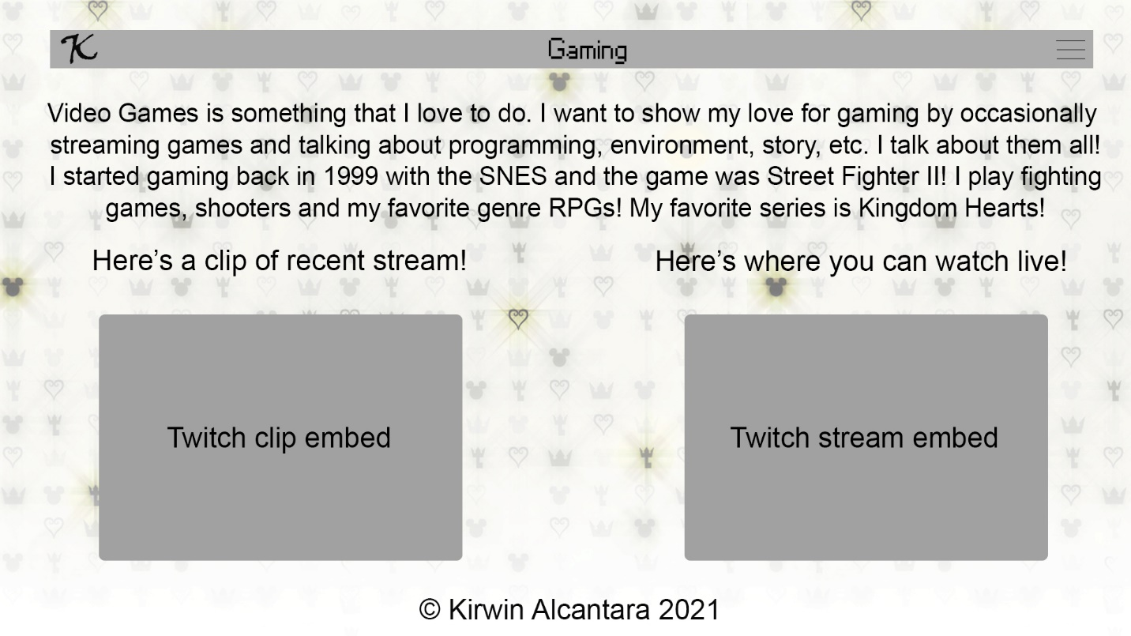

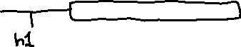

Gaming page is very close to final. I have to play around with the background and text alignment but for the most part this is it. A lot of outside Javascript needed here (I have it saved, just need to test and play around with it). The mobile page will have the clip embedded first and then the Twitch stream coming after in the same format.

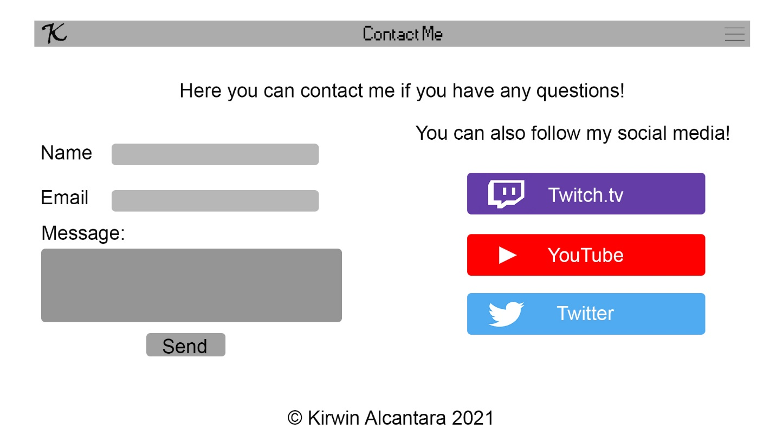



Lastly, the contact page doesn’t have a background. I don’t have a solid idea of what theme I plan to use but the layout is great to me. I’ll probably change the size of the social media buttons and most likely the little text on top. The buttons might be an image that leads to each my profiles. I should include my LinkedIn as I write this now. For the most part, this is how the contact page will be.

